Case 6-DR Congo-Songye Mask-Frontal Ridge-Raffia-Early 20th c

*Note: The Democratic Republic of the Congo (DR Congo) has been known as, in chronological order, the Congo Free State, Belgian Congo, the Republic of Congo-Léopoldville, the Democratic Republic of the Congo and the Republic of Zaire, before returning to its current name the DR Congo.*

*Note: The Kongo people (singular: Mukongo, pl. Bakongo) speak Kikongo, a Bantu language, who have lived along the Atlantic coast of Central Africa, in a region that, by the 15th century, was a centralized and well-organized Kongo Kingdom but is now a part of three countries: DR Congo, the Republic of the Congo and Angola.*

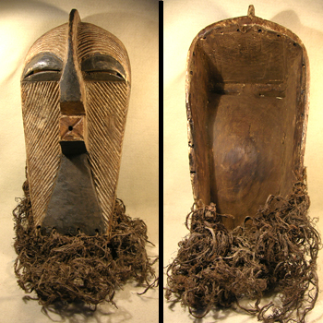  
I am pleased to offer this rare and incredible Songye Kifwebe mask. Carved with linear designs and remains of black and white pigment, the mouth is square and protruding. The white color and low ridge crest indicates this mask is "female" in gender. Female masks are primarily white, forms are restrained and elegant with striated surfaces. Their function was to awaken and honor benevolent spirits. Holes for fiber attachments around the edges. The plant-fiber fringe is still attached along the bottom and appears to be completely original. Overall in excellent condition with expected (and very desirable) wear from extensive tribal use. Experienced collectors will appreciate the fine quality and age of this exceptional artifact. With wear patterns and perspiration staining in all the right places, this mask could easily be the centerpiece of any collection. By far the best mask of this type I've ever seen. It doesn't get any better than this. Please ask if you would like to see additional photographs of this superior example.   
  
Mask is 16" tall (24" including attachments) x 8.5" across   
  
SOLD